Python Introduction & Setup

Introduction to Python Programming

# Overview

Welcome! In this module, we are going to focus on installing the Anaconda distribution of Python 3.x.

The Anaconda distribution of Python is a very popular way to install Python. This is not only because it is an easy way to install Python, but it also includes many Python libraries that are popular for machine learning, data science, and web apps.

We will also introduce Jupyter Notebook which is an application that helps you write Python code. It has some unique features that are especially useful for data exploration, model development and prototyping, and learning.

# Introduction to Python

Python is a very popular and “easier”-to-learn programming language that is used for many applications including scripting, machine learning, data science, and web apps. It’s relatively easy to learn and widely applicable, making it a great choice for beginners, and also for experienced programmers that want to add to their skill stack.

Python was developed to be a “beautiful” language without unnecessary complication. The first few lines of the [Zen of Python](https://www.python.org/dev/peps/pep-0020/) (a set of guiding principles for writing programs) capture the essence of the development goals of Python:

“Beautiful is better than ugly.

Explicit is better than implicit.

Simple is better than complex...”

# Introducing Anaconda

Anaconda is a company that provides a distribution of Python that is very easy to install, and which contains many popular Python packages used for machine learning, data science, and web applications. Python, and the additional Python packages installed in the Anaconda distribution, were not created by Anaconda; and though Anaconda has commercial products available, the Python distribution is free and open source (i.e., free to download and redistribute). It is possible to install Python and the additional packages independently (i.e., outside of Anaconda), but doing this takes more time and can be complicated. Anaconda makes downloading easy, and therefore, is an especially good choice for beginners. Due to these reasons and more, professionals in the field frequently utilize Anaconda.

One of the additional pieces of software included through Anaconda is Jupyter Notebooks, which we will introduce next.

# Introduction to Jupyter

Jupyter is a lightweight *integrated development environment* (or IDE). An IDE is simply an application that lets you write text, but also has some additional attractive features specific to writing code. Code, in its essence, is just “text”, so Python could be written in Notepad, TextEdit, or even Microsoft Word. However, writing code within these programs can be a little awkward, and there aren't any of the additional features that an IDE provides. Just as Microsoft Word provides useful features that help create and manipulate documents and reports, integrated development environments provide lots of great features for writing, debugging, and running code.

*Jupyter Notebook* was developed to be like a scientific notebook, except for programmers and data scientists. You may remember from a chemistry or physics lab in school that you were required to keep a notebook so you could document your experiments, i.e., track all the steps that were taken and the results. You could then share your notebook with others, so they could see all the details of your experiment. This is the idea behind Jupyter Notebooks, which are very interactive and excellent for prototyping, data analysis, data science, and machine learning. A Jupyter notebook will contain your plots, comments, results, and your code, and can be easily shared with a colleague. You can even run shared notebooks on a server with [*JupyterHub*](https://jupyter.org/hub).

All of this being said, the best way to really learn about Jupyter Notebook is to use it! We will do this in our course lectures.

# Installing Anaconda

Now that we have introduced Anaconda, let’s install it!

First, go to <https://www.anaconda.com/> and in the upper menu, select ‘Products’ and then ‘Individual Edition’ as seen in Image 1 below.

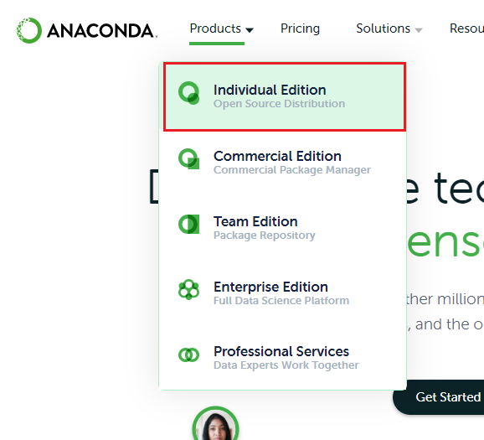

*Image 1: Screenshot of Anaconda product dropdown menu*

Then, scroll down close to the bottom of the page to the “Anaconda Installers” section as seen in Image 2.

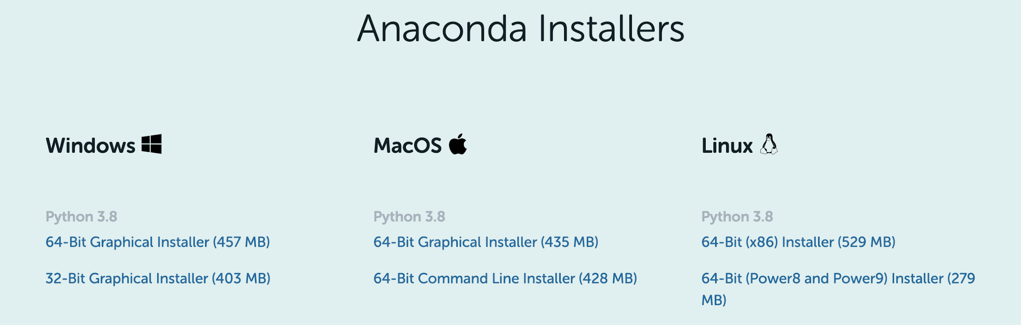

*Image 2: Screenshot of Anaconda product installer links*

Choose the correct “64-Bit Graphical Installer” for your system.

After the installer downloads, simply open the installer and follow the steps. It will be very similar to the installation experience you have had with other software.

Once you download and install, you are now ready to dive into the lectures for this week!